1.) grep - I

This command ignores the case for matching

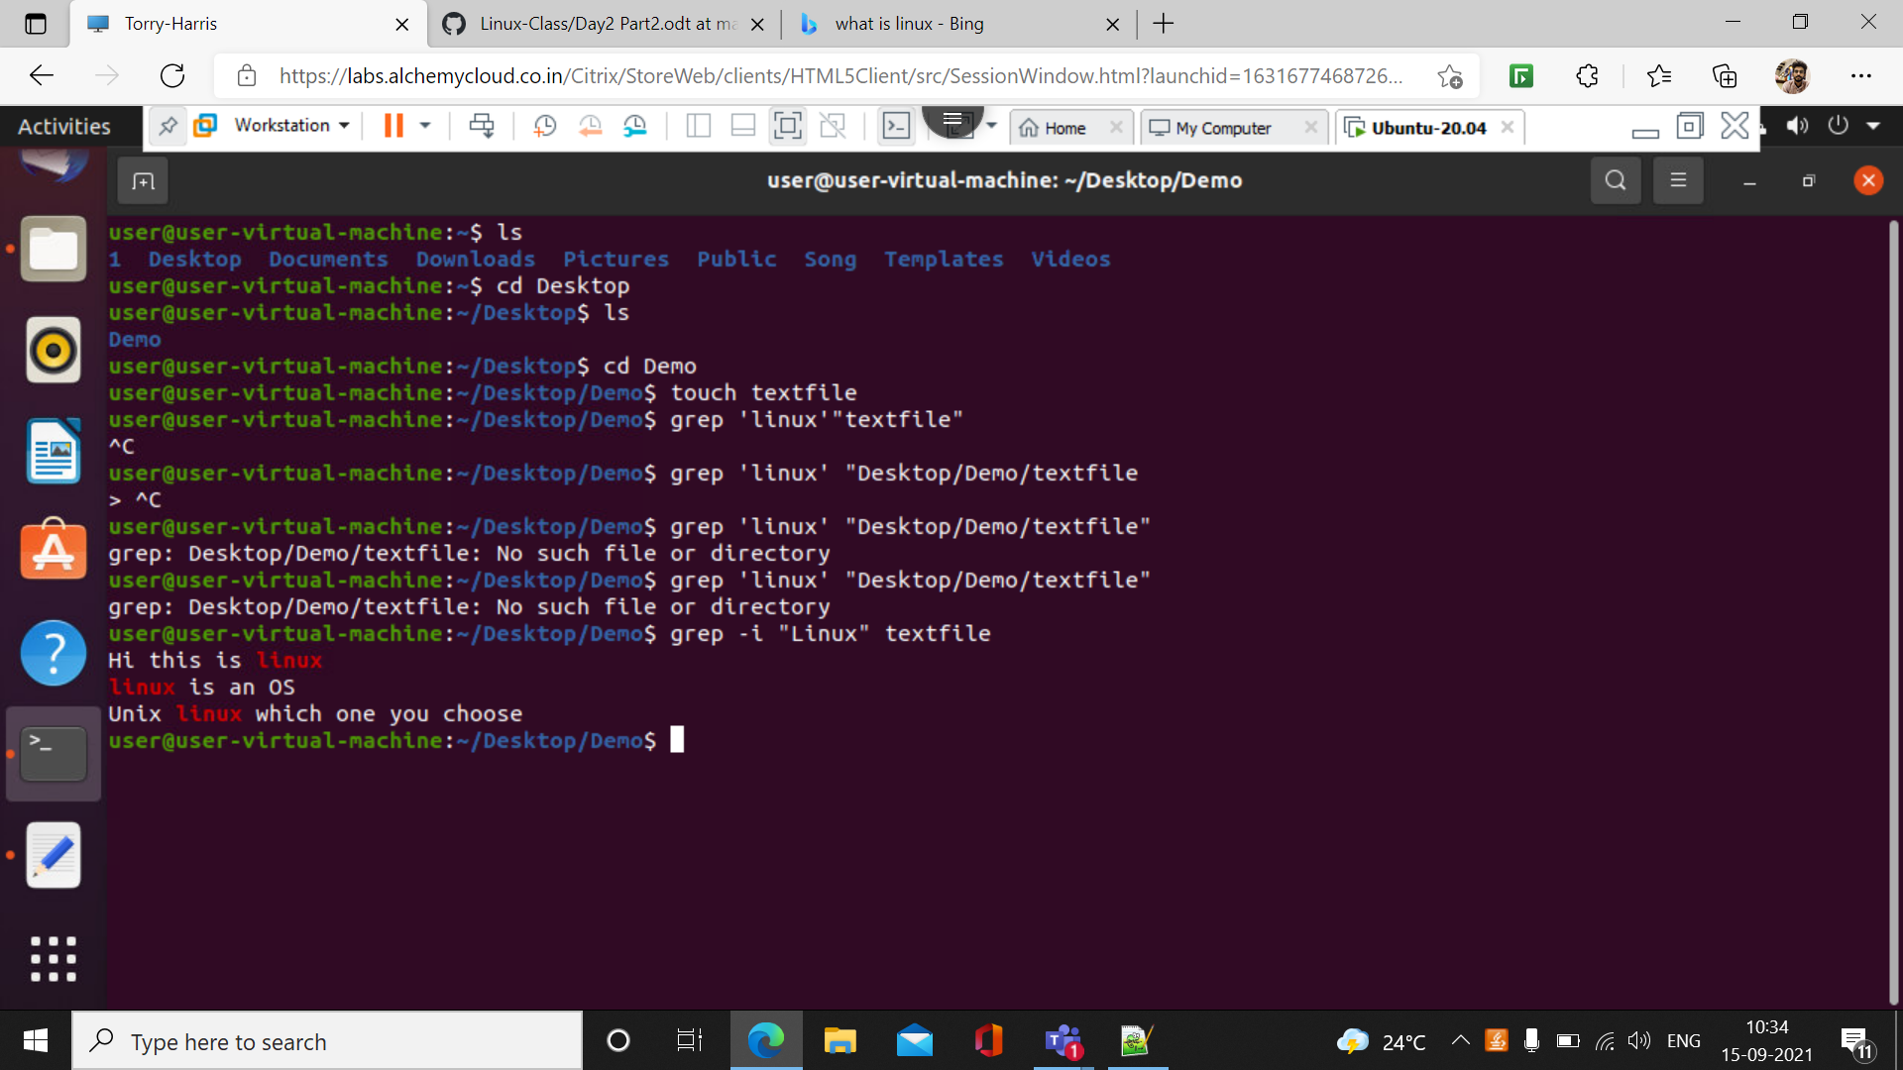

2.) grep – c

This command prints the number of counts of lines that are matched

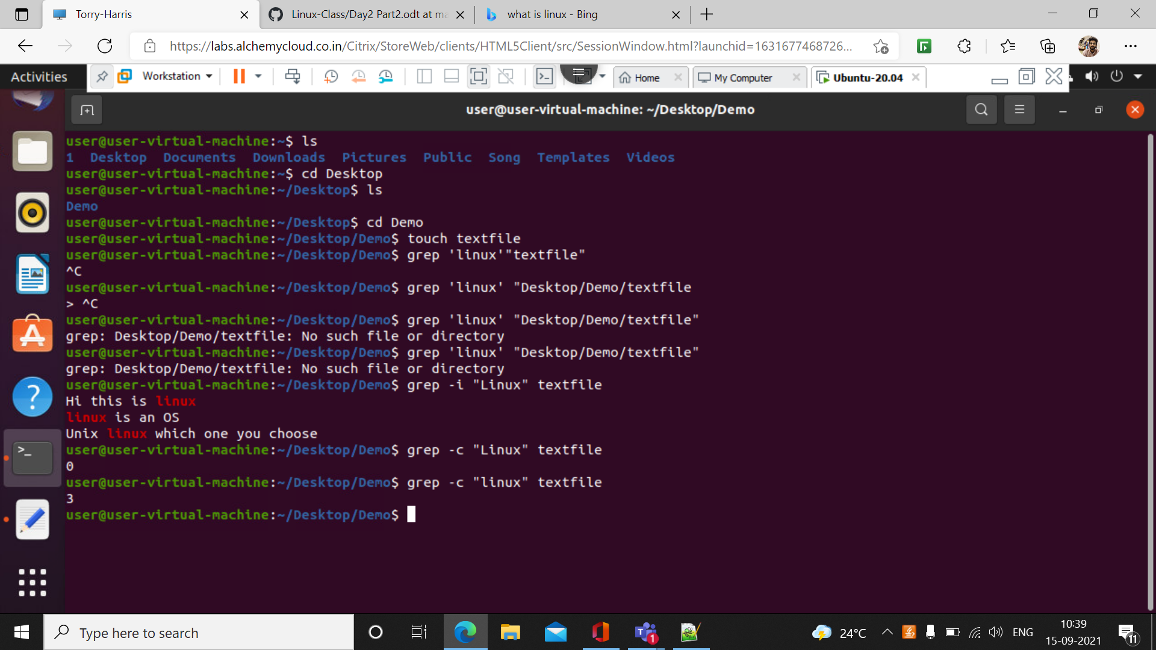

3.) grep –l

This command is used to display the list of file name

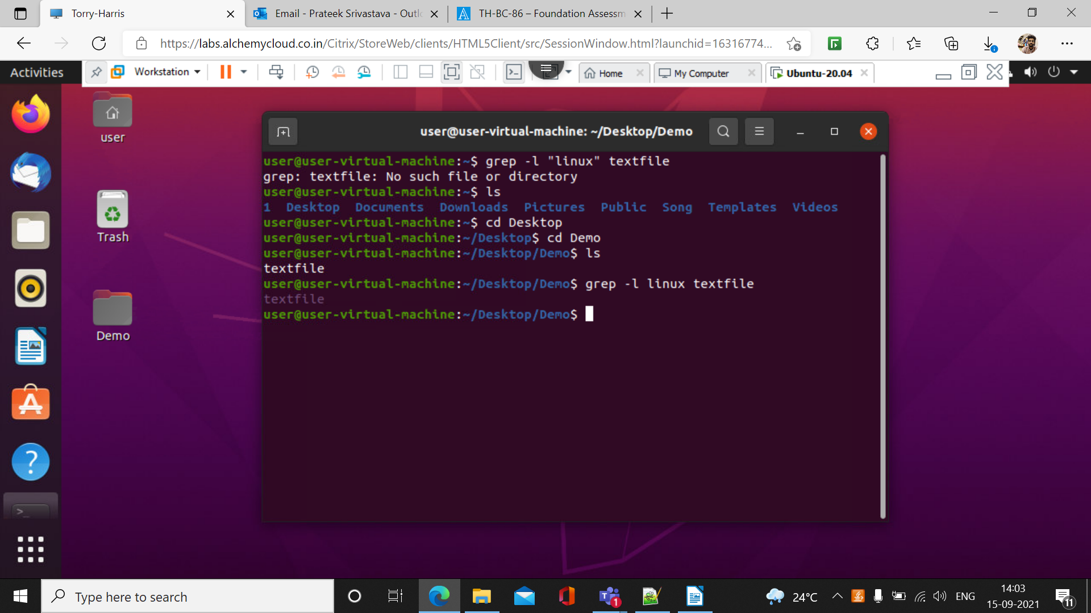

4.) grep -w

This command is used to match all the words

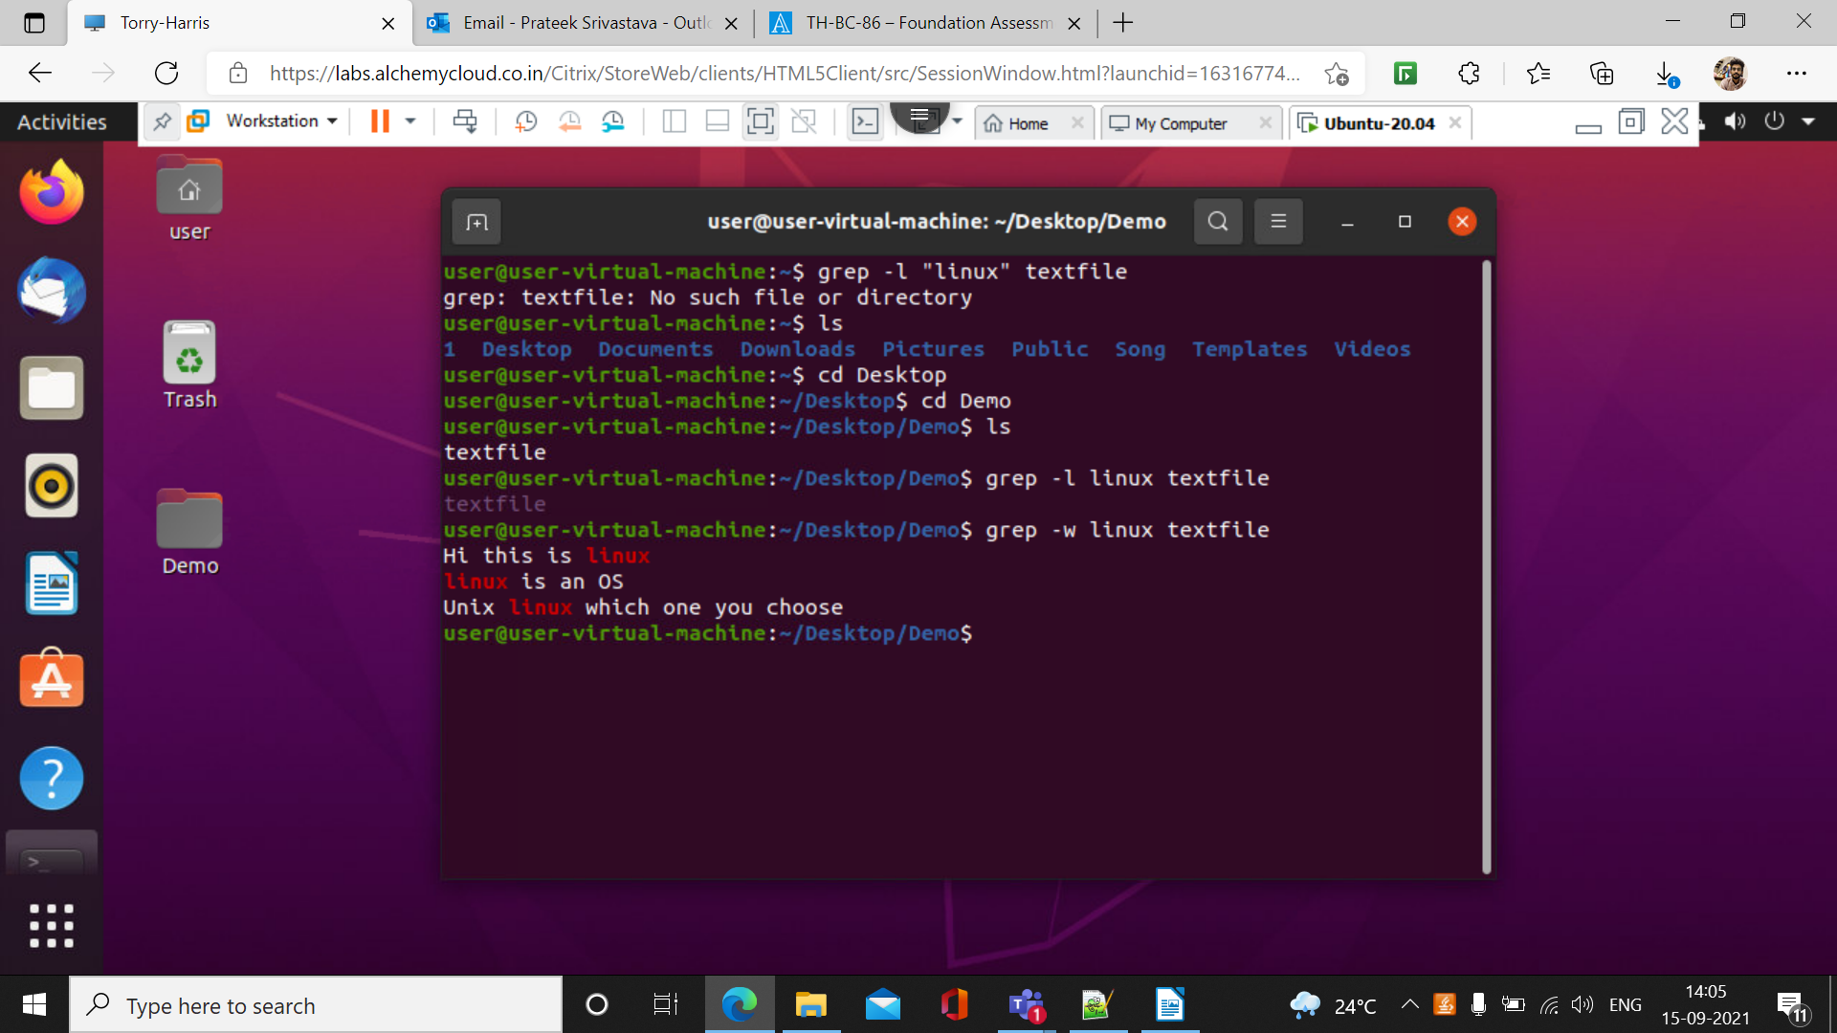

5.) grep -o

This command is used to display the matched part of the matching line

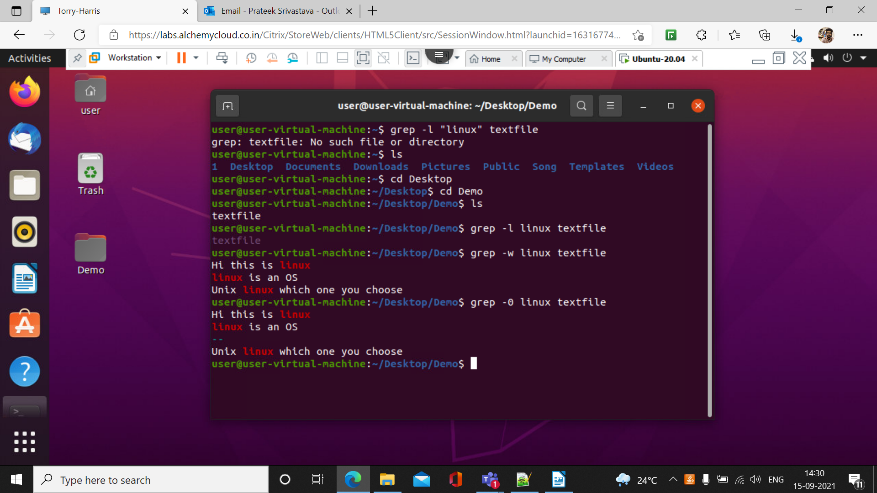

6.) grep -ow

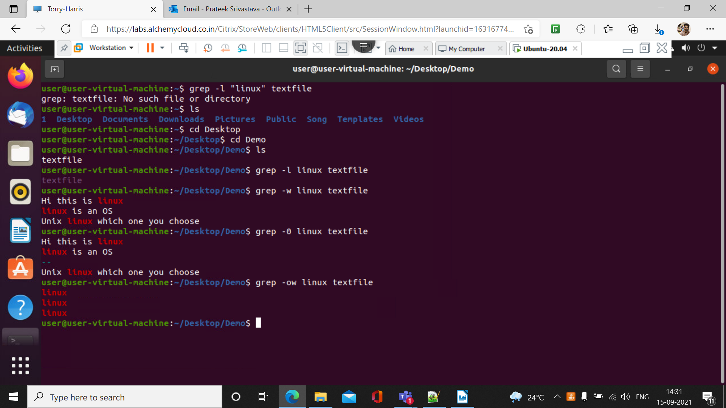

7.)grep -o -i

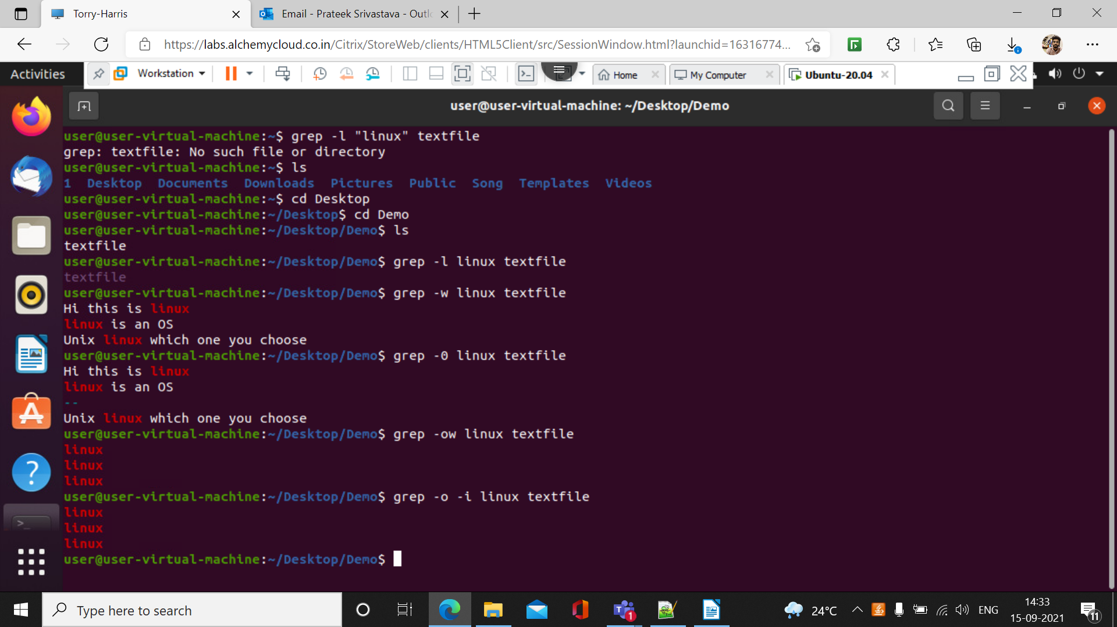

8.)grep -v

It display all the lines that do not matches the pattern

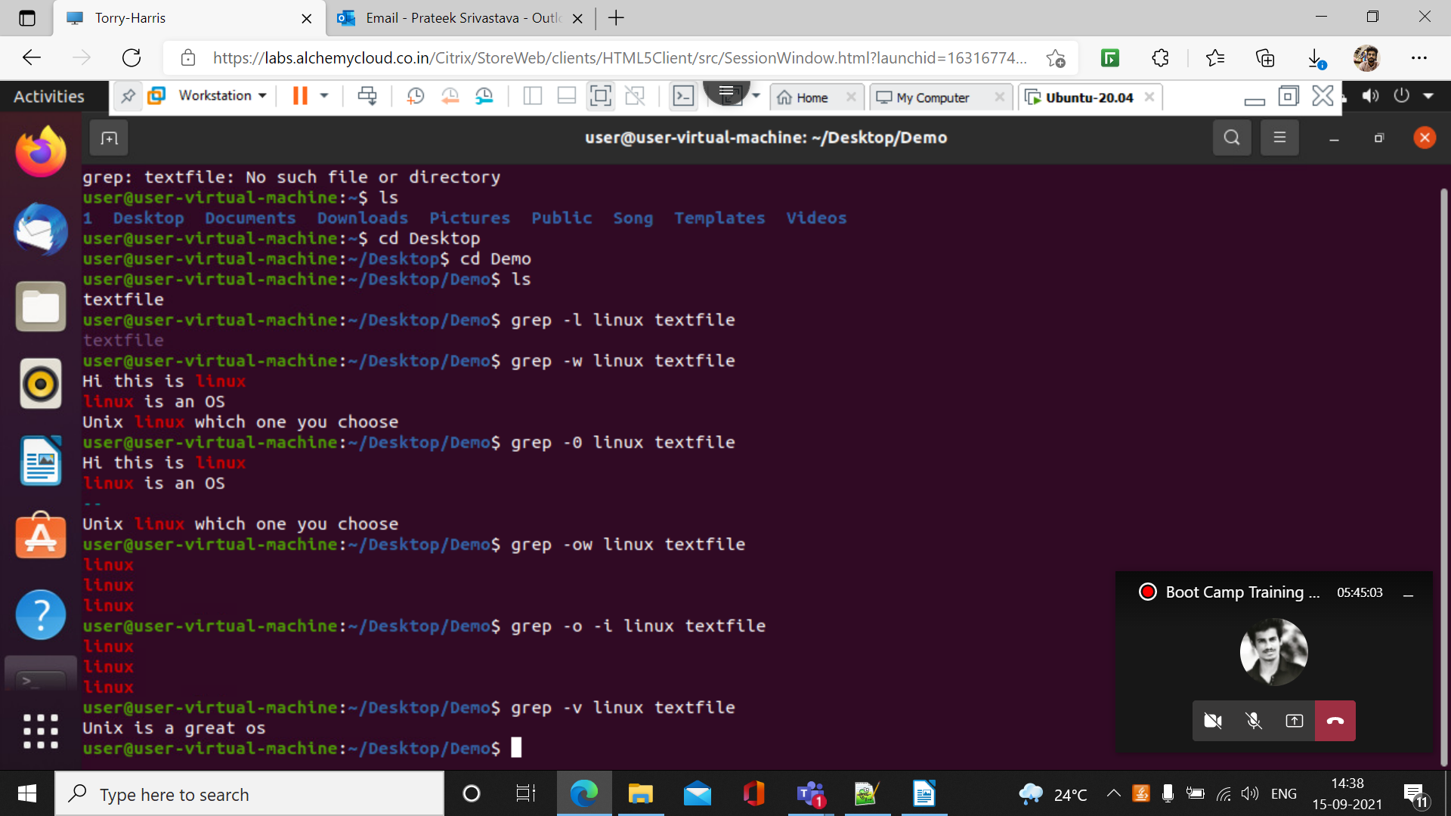

9.)grep -vi

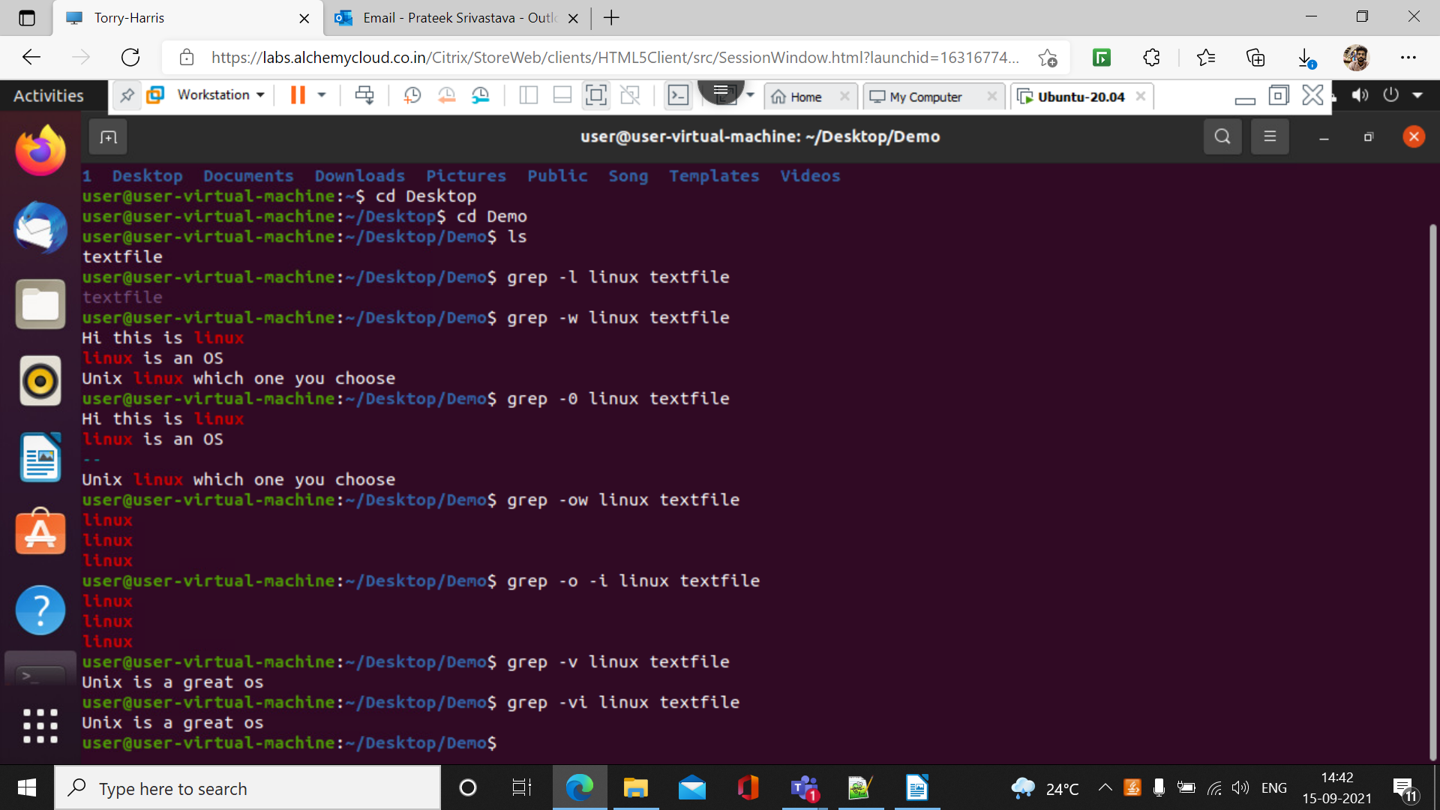10.)grep ‘^linux’ textfile

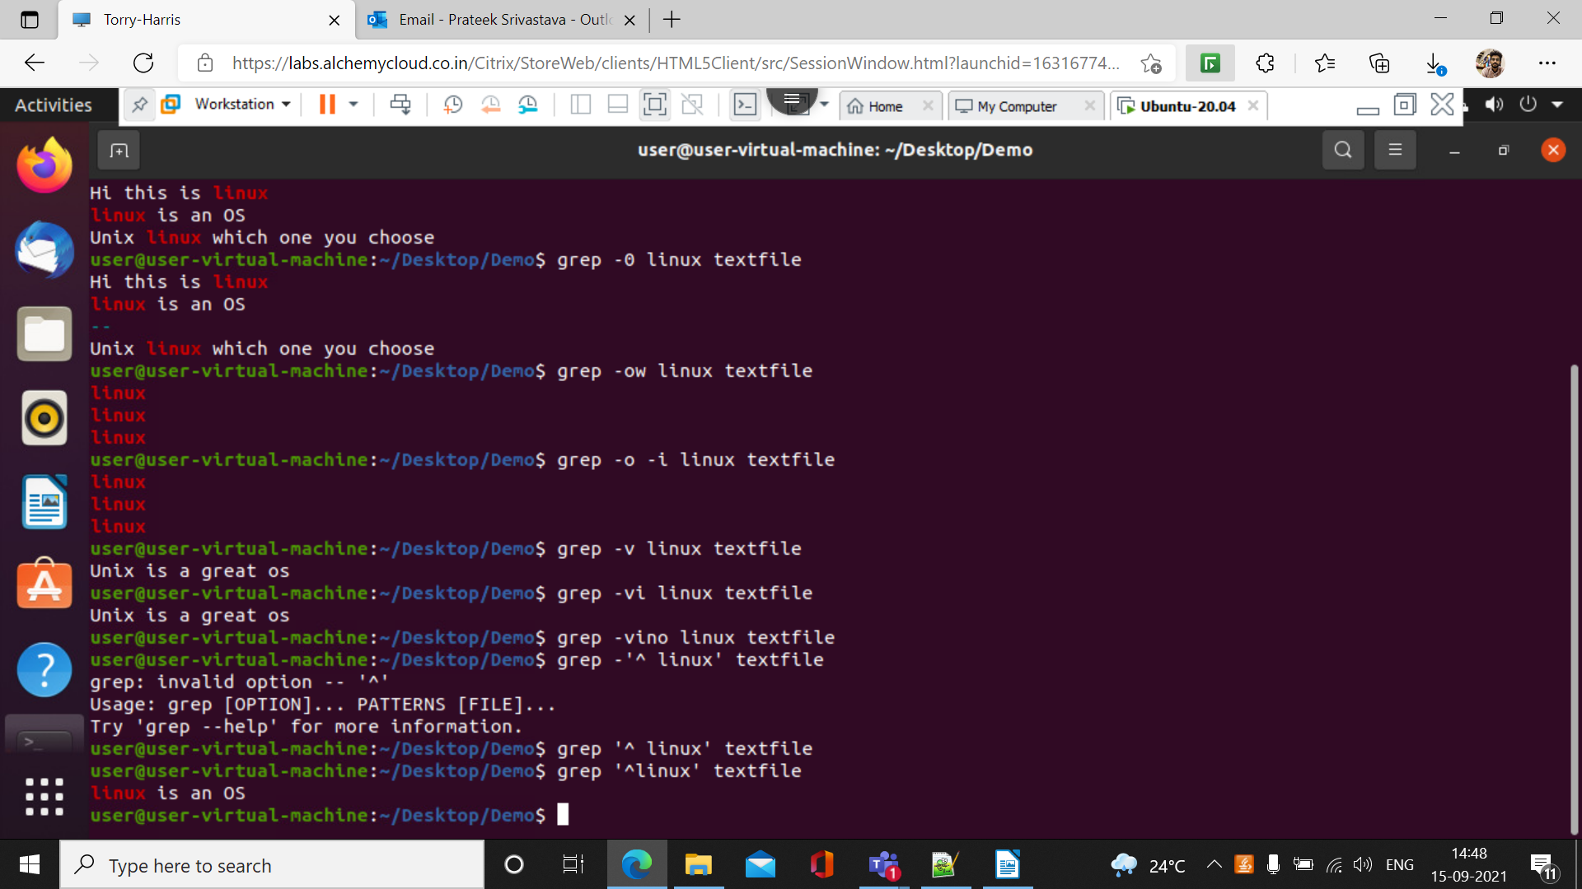

11.) gerp -ni -E ‘^h[i]\*p$’ ‘f2’

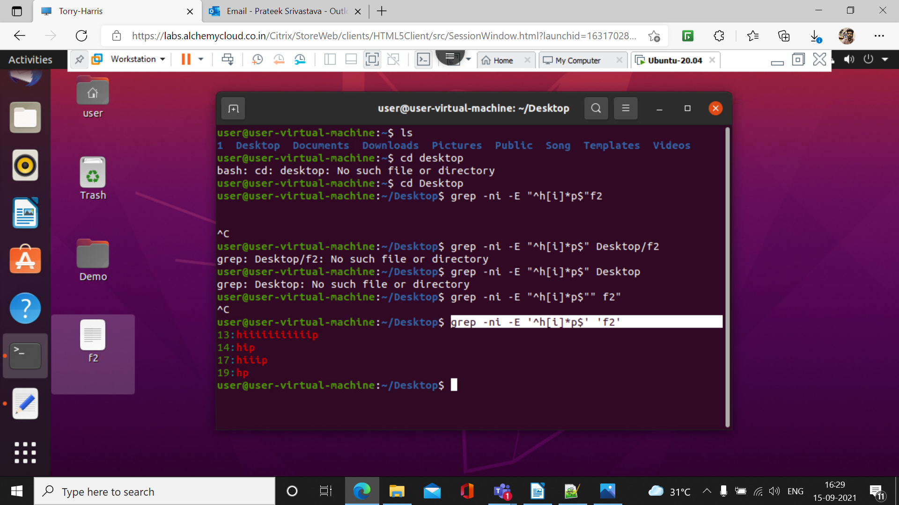

12.) grep -ni -E’^h[i]p$’f2’

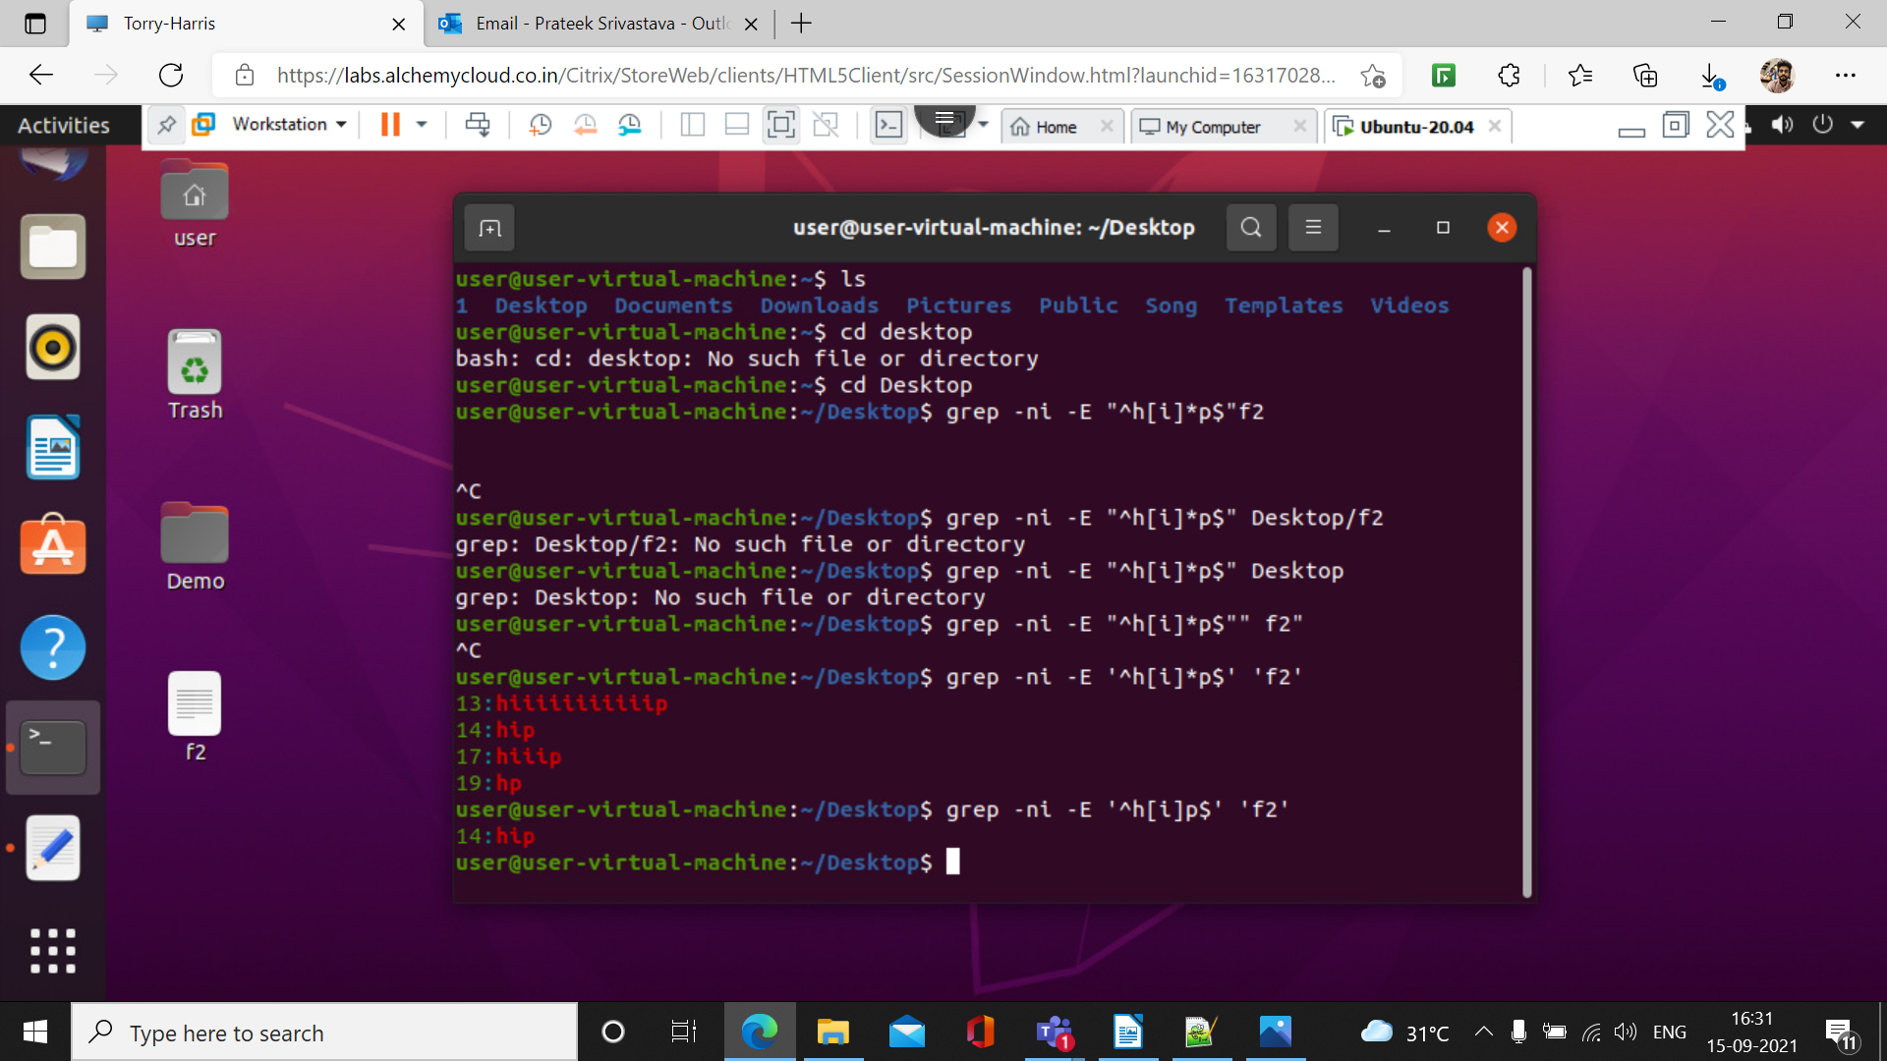

13.) grep ni -E’^h[i]+p$’ ’f2’

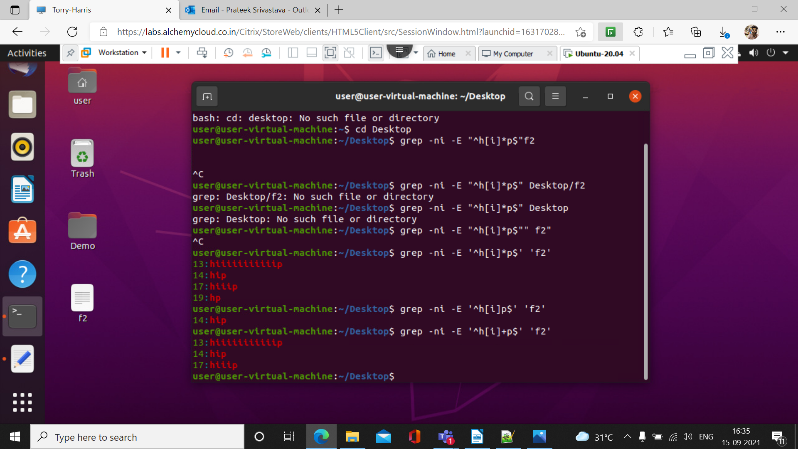

14.) grep -ni -E ‘^c.’ f2

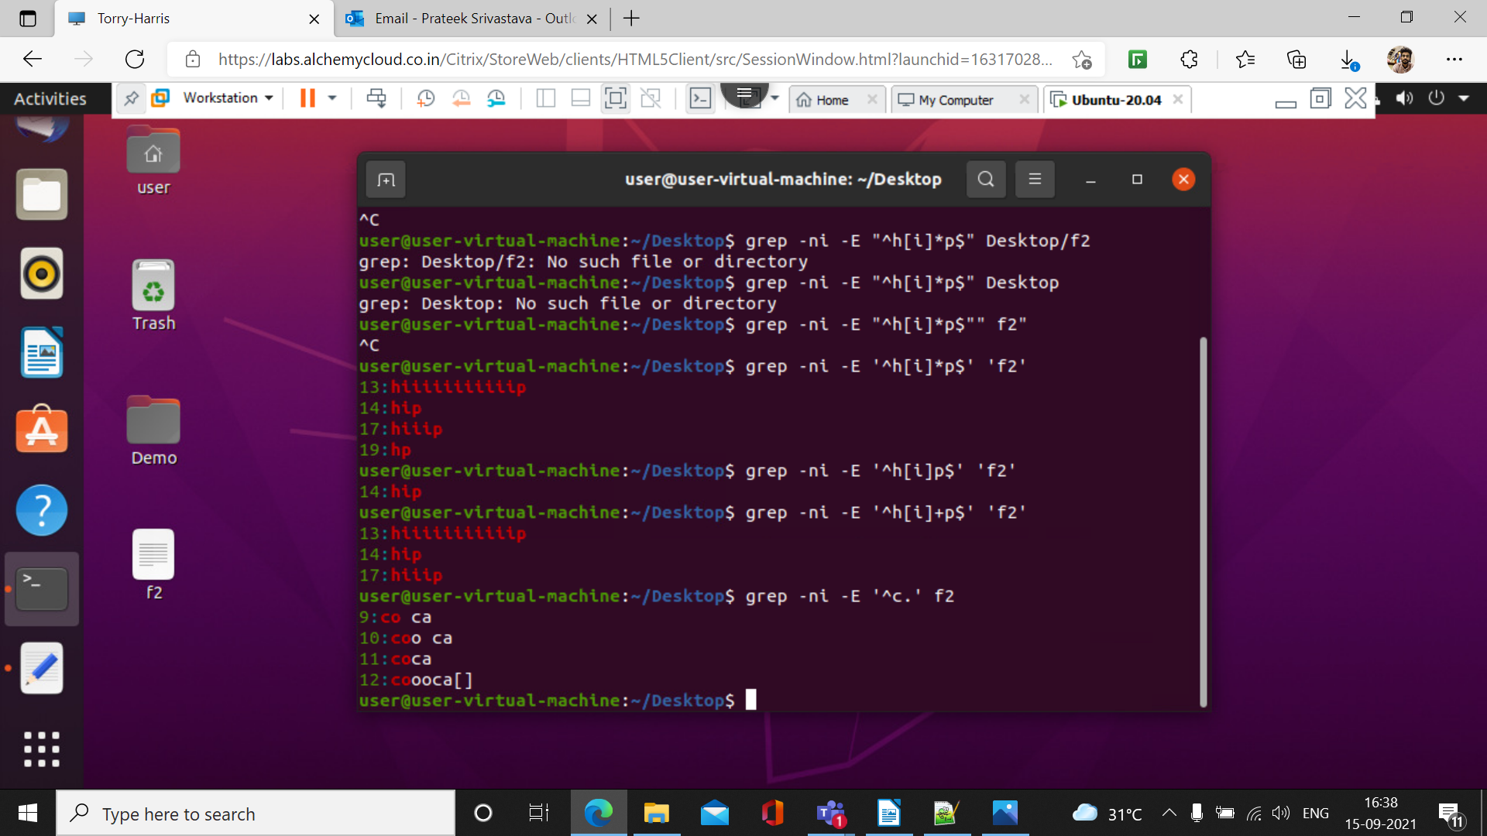

15.)grep -ni -E ‘^h[^l].\*o$’ ‘f2’

This command is used to print all the lines that start with the word h and ends with the word o

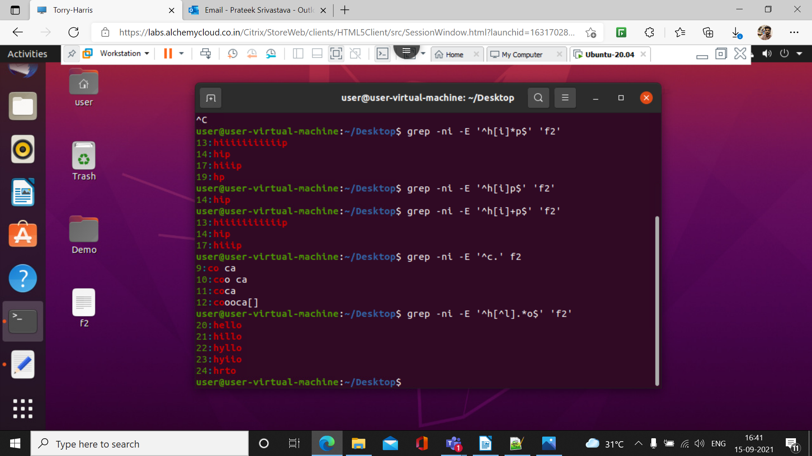

16.) grep ni E ‘[A – Z].\*’ f2

